Jadavpur University

Department of Electronics and Telecommunication Engineering,

Faculty of Engineering & Technology

DSA LAB REPORT

2nd Year First Semester 2020



Name : RAHUL SAHA

Roll: 001910701009

Group 1

IMPLEMENTATION OF QUEUE USING STATIC AND DYNAMIC MEMORY REPRESENTATION

Assignments - 04

1. Implement a Queue using i) a fixed memory representation and ii) a dynamic memory representation. In both cases, you should implement the two primitive operations, namely, insert and delete with proper guards. You should experiment with a set of insert and delete operations. Show the contents of your queue after each operation.

Solution(s)

1. Using fixed memory representation -- Using Array

CODE

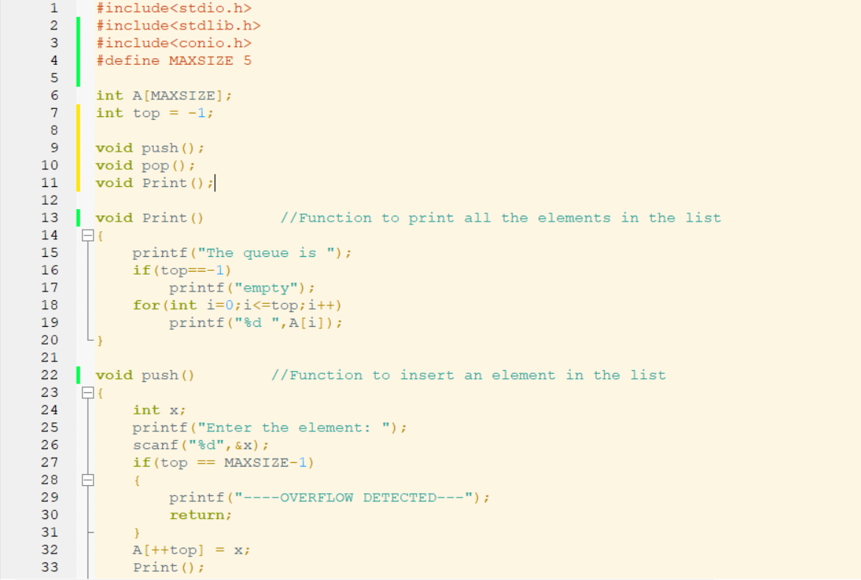

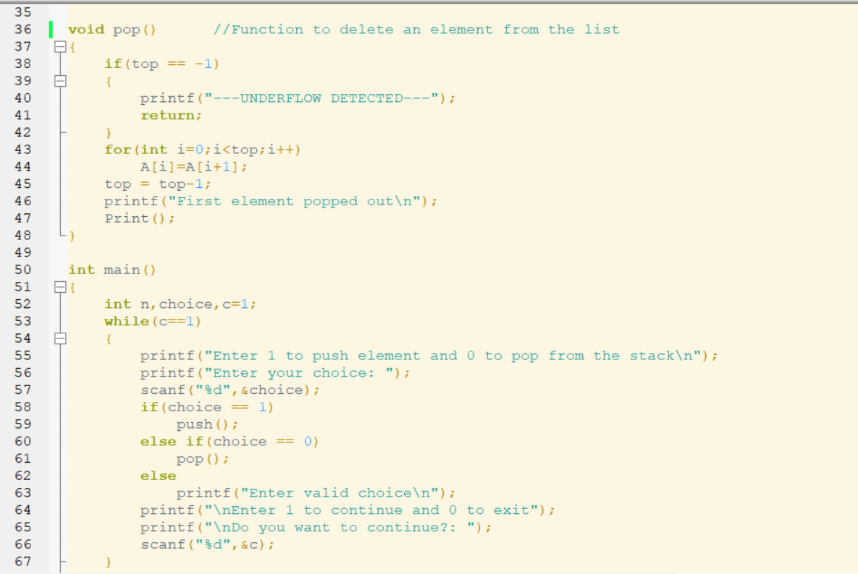

OUTPUT(S) :

1. Push Operation

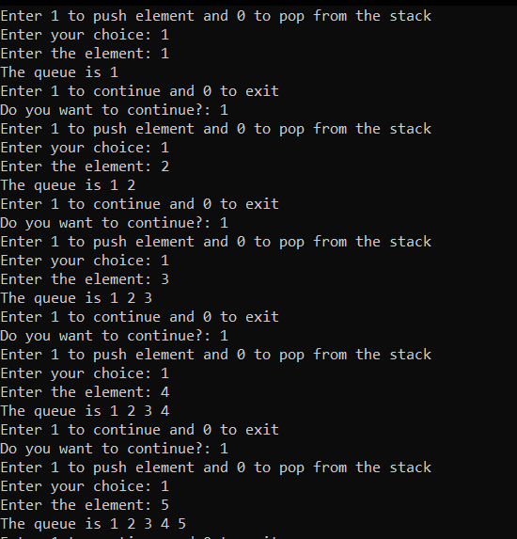

1. Overflow Detection ( When number of elements is more than MAXSIZE)

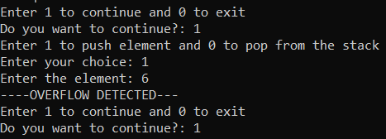

1. Pop Operation

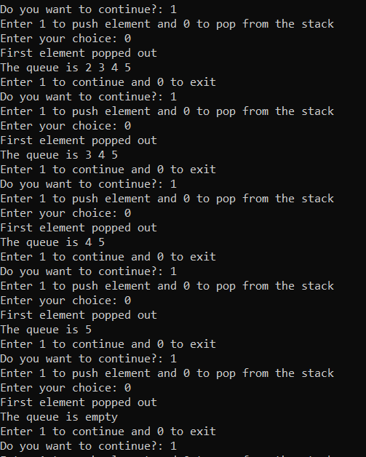

1. Underflow detection

4.1 When pop operation is applied on empty list

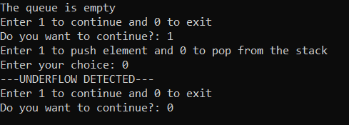

4.2 When pop operation is done before insertion

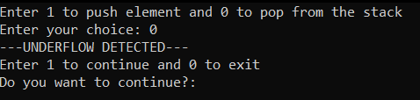

2. Using dynamic memory representation -- Using Linked List

CODE:

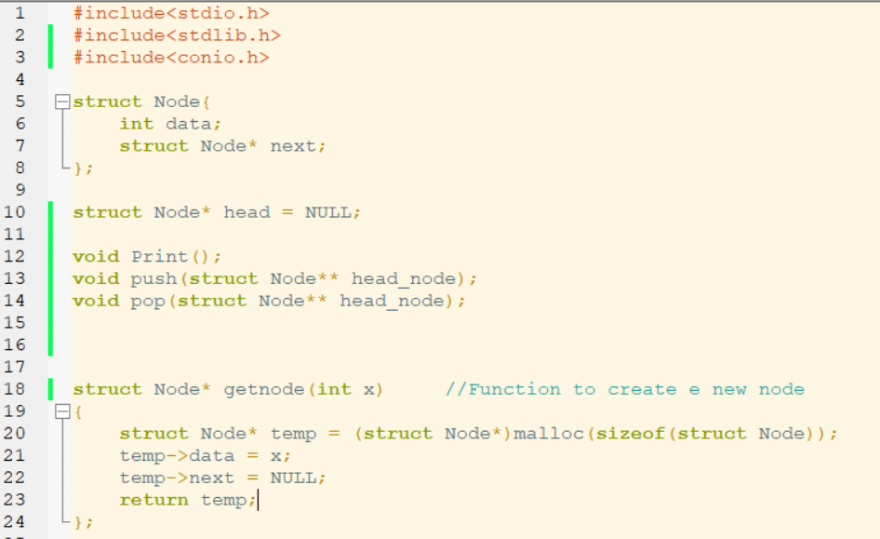

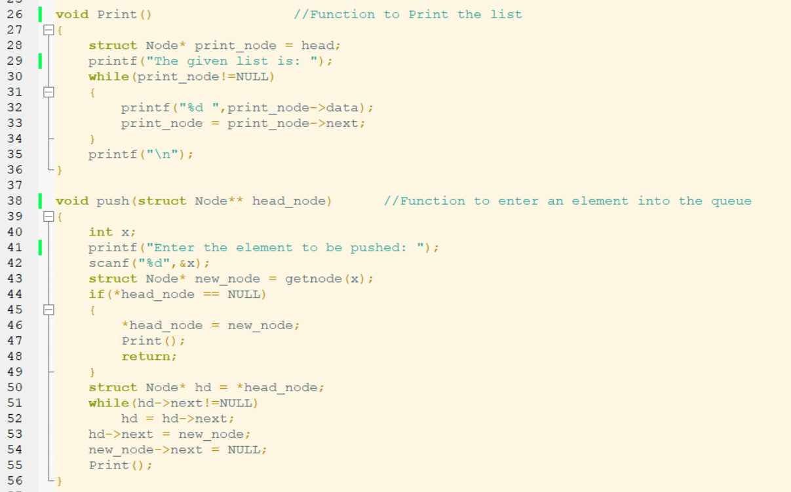

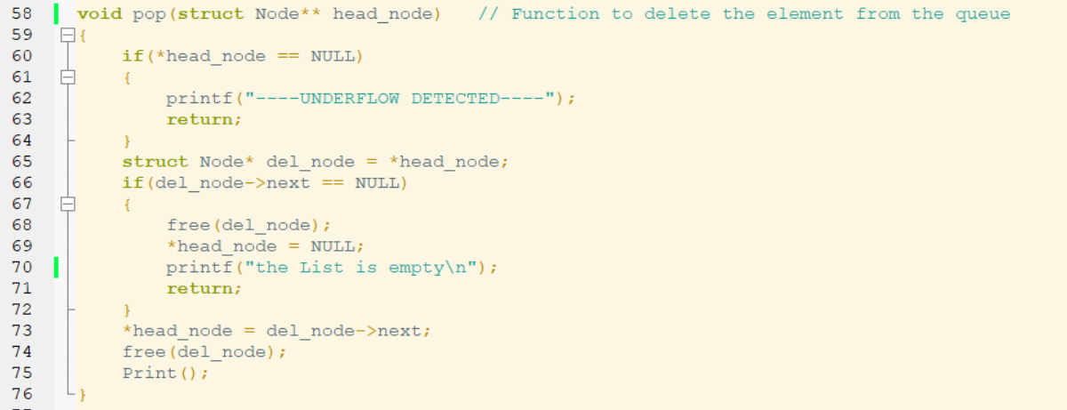

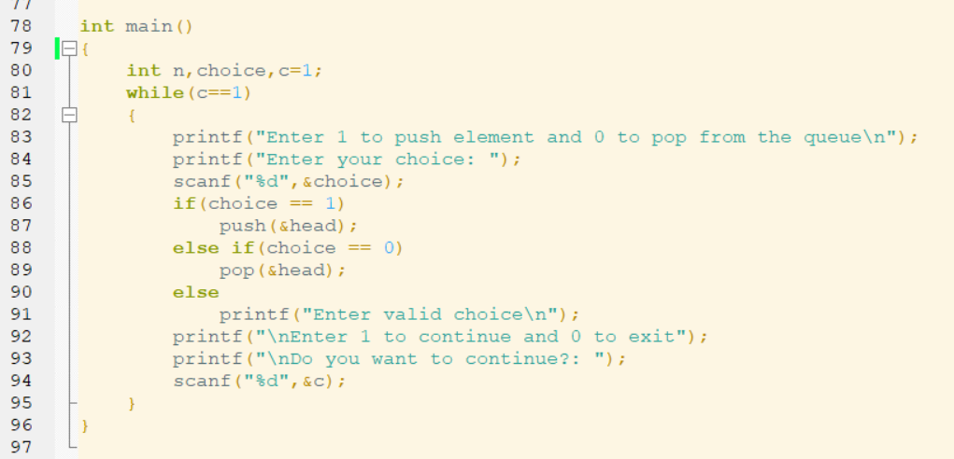

OUTPUT(S):

1. PUSH OPERATION

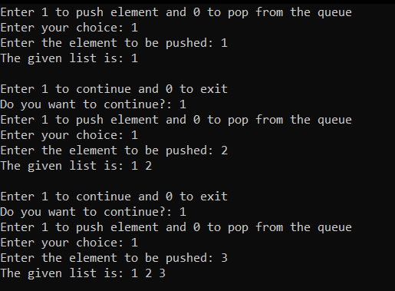

1. POP OPERATION

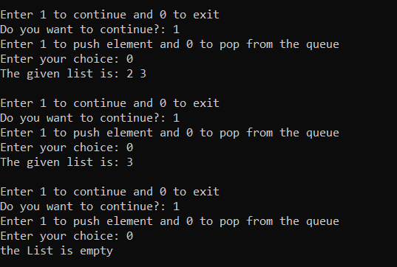

1. UNDERFLOW DETECTION

3.1 When Pop operation is done in empty list

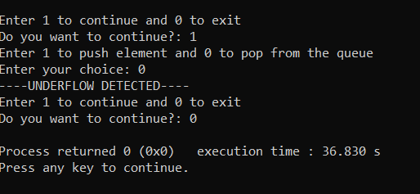

3.2 When Pop operation before insertion

